Title: Applying EOQ and Lean Principles in Inventory Management
Objective: To help students understand the EOQ formula, decompose it and understand how the behaviour of individual variables affects inventory decisions. I also want students to understand the applicability of lean principles across a range of inventory management conditions. This workshop builds on the games from previous workshops, in that I ask them to make more decisions, only now students need to evaluate alternative strategies and how they perform (i.e., using a forecast to order mangoes vs. Using the EOQ formula). Note: despite the apparent simplicity of the game, you have more than one choice to make. Do you issue orders every day? Or do you use the EOQ and calculate the frequency of orders as well.
Learning Objectives
- Understand the EOQ formula, and how its components affect order quantity and frequency
- Demonstrate application of lean principles.
- Understand how inventory management decisions manifest in a sawtooth diagram.
Introduction:
- Begin with a brief overview of inventory as an accumulation, and how decisions made by operations managers affect this accumulation. Review the concept of the sawtooth diagram. Also ensure students are aware that inventory, although costly, is a necessary asset in matching supply and demand. Primarily when the rate of production does not match the rate of consumption.
- Explain lean principles to determine what is and is not being classified as waste, as a target for elimination. Inventory can be wasteful at times if the inventory is not capable of producing value immediately and serve a valuable purpose in being a buffer between production points and demand points in the supply chain.
- Explain the Mango Inventory Management simulation to practice real-world inventory management decision making. The emphasis (again) is for the students to be placed in a position where they make inventory management decisions, they can choose to do this several ways (as in real life), but they should keep in mind that the inventory management principles and lean principles shown in modules 5 and 6 have real value in their application.
Game Overview (10 minutes):
- Present an overview of the Mango Inventory Management game, read the instructions carefully, including its rules and objectives. Take the time to explain the setting, and how this can manifest in real world settings. Also remember that they should not just ram numbers into the game, and that you (the tutor) will be asking them the questions; “what would you do?” And “why?”
- Also keep in mind I have placed financial constraints on the game, so their starting cash on hand is all they must make an order on the first turn. As the game progresses, as soon as cash in hand goes too low, the game ends or prevents the ordering of inventory (so there is a way to lose). The formula here is a derivation of the total cost function, assuming zero demand, so it incurs the maximum Ch. This calculation has now been automated in the simulation. Please do not present this formula to students.
- Ask the students what information they would use to decide, I suspect students will mostly avoid using the EOQ formula and instead will default back to the previous tutorial where forecasting was key, they will try to create a forecast and base that as the order quantity. In some cases, they may even entirely ignore the ordering costs and holding costs, if this is the case then use the two questions above to query their decision-making heuristics. Feel free to play it out this way first (keep in mind I have balanced the game so that EOQ is a superior policy). Happy for you to play it out this way, record the results, and move on. In discussion, ask the students whether they balanced out the individual costs, did they balance order quantity, holding costs, and ordering costs in the game?
- Ask students to interpret the sawtooth diagram, help them out if they cannot understand it. This could need a bit of a review of the inventory management module for some. The graph shows three data points for every turn, the inventory before replenishment and demand, inventory after replenishment but before demand, and inventory after replenishment and demand (forming the three points for every turn).
EOQ Introduction (15 minutes):
- Introduce the Economic Order Quantity (EOQ) formula (p452-454 in textbook):
  - EOQ = √((2 * D * Co) / Ch)
    - D = Annual demand
    - Co = Ordering cost per order
    - Ch = Holding cost per unit per year

- Explain the concept of EOQ and how it helps in determining the optimal order quantity to minimize total inventory costs. Keep in mind the forecast they generated is still useful here, as the D variable needs to be informed by something, as the decisions they are making now will play out in the future. In other words, they need to make decisions before demand manifests itself.
- In some instances, the EOQ they determine using the formula will be more than the forecast, or even less than the forecast. Keep this in mind as the EOQ requires consideration about quantity and order frequency. Ask students how they adjust the order frequency to a determined Q and vice versa. Take some time and explain the order frequency formula as follows:

- Feel free to use a spreadsheet in the one drive to better automate the calculation process. No need to spend time running the calculation repeatedly if a more efficient way is available. Just keep in mind that you should not share the spreadsheet with students as they should be able to do this on their own.
- In the V1 configuration of the mangoes game, your EOQ should be around 4000, which is difficult to achieve without building up some cash first. One option is to order 1700 in the first turn, and order zero for the subsequent turns until inventory gets low. Once inventory starts to get close to zero, order 4000 or thereabouts. This should cover the demand until turn 10 or so. Discuss the resulting sawtooth diagram. It should look something like this

EOQ Impact on Costs: Discuss how changing the values of Co and Ch can impact the calculated Q and costs:
- Increasing Co (Ordering Cost):
  - Explain that a higher ordering cost (Co) increases the EOQ, which means ordering in larger quantities.
  - Emphasize that this may reduce the frequency of ordering and holding costs will increase but decrease ordering costs. Keep in mind that if this increases dramatically, you would not be issuing orders every turn. I would like students to arrive at this conclusi on themselves, but feel free to help them along.
- Decreasing Co (Ordering Cost):
  - Explain that a lower ordering cost (Co) decreases the EOQ, leading to smaller order quantities but more frequent orders. Keep in mind that decreasing this dramatically will lead to a small Q and an increased risk of stockouts.
  - Try to relate the concept of stockouts against the lean principles of eliminating waste. Keep in mind the increasing Q idea I wrote about earlier will inherently create more waste, as inventory will be held and not used. Ask students what will happen to their performance if they hold too much inventory. Aim to have students arrive at a conclusion relating lowering Q and trying to reduce inventory.
- Increasing Ch (Holding Cost):
  - Explain that a higher holding cost (Ch) decreases the EOQ, resulting in smaller order quantities and more frequent orders.
  - Emphasize that this may reduce holding costs but increase ordering costs. Relate it back to lean principles and how holding costs are likely to elevate the preference for adopting lean principles.
- Decreasing Ch (Holding Cost):
  - Explain that a lower holding cost (Ch) increases the EOQ, leading to larger order quantities but fewer orders.
  - Emphasize that this may reduce holding costs and lower the preference for lean principles.
- They should arrive at the conclusion (help them if needed) that decreasing ordering costs and/or increasing holding costs should lead to smaller, more frequent orders and a sawtooth diagram that more closely reflects lean principles (as average inventory is much smaller). If you have time, you can run V2 of the game where I changed Ordering costs to $150 and holding costs to $0.70 (EOQ comes out to about 600 in that version). The sawtooth diagram should look a bit more like this.
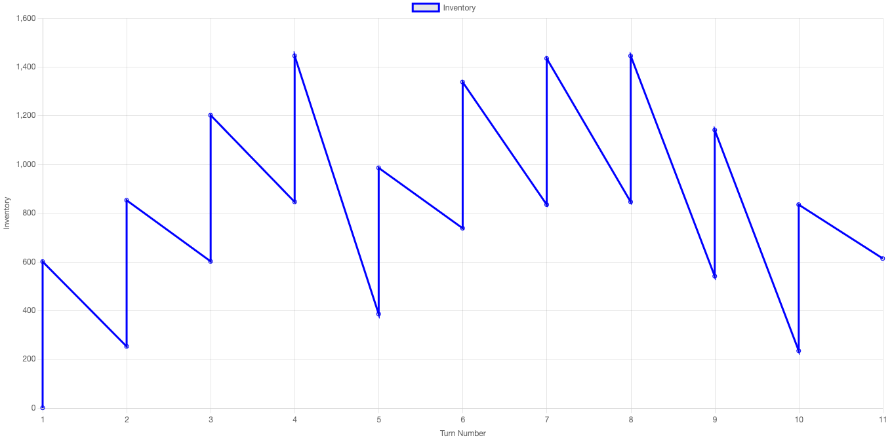
Discussion and Analysis (15 minutes):
- Discuss the advantages and limitations of using the EOQ formula in practice, especially when dealing with variable costs. They need to understand that EOQ also requires an adjustment in order frequency and that it is not simply a model to generate order sizes.
- What assumptions are taken in this model that introduce risk (i.e., things that are assumed to be irrelevant, that would make the EOQ approach not work or inferior to other approaches)?
- Encourage students to reflect on their inventory management decision making processes and heuristics in the game, considering different scenarios, and seeing how the manifest different sawtooth diagrams.
- Optional: If you have time, ask questions about perishability. Assume the mangoes, as a perishable product incur a penalty if they remain unsold and need to be disposed of;
  - How does perishability affect order quantity decisions? Ask students to think about how the risk of mangoes becoming unsellable due to perishability influences their order quantity decisions. Does it make them more conservative with order quantities to minimize the risk of waste? How does this align with or conflict with EOQ principles?
  - Balancing Perishability Costs with EOQ Costs; Encourage students to analyse the trade-off between minimizing perishability costs (disposing of unsold mangoes) and minimizing traditional inventory costs (ordering and holding costs). How do changes in ordering costs (S) and holding costs (H) affect this balance? Does the EOQ formula still provide an optimal solution in this context?
  - Strategies for Managing Perishability; Challenge students to brainstorm and discuss strategies for managing perishability within the game. What actions can they take to reduce the risk of mangoes going unsold? Are there ways to adjust ordering frequency or quantities to account for perishability while still optimizing costs?

